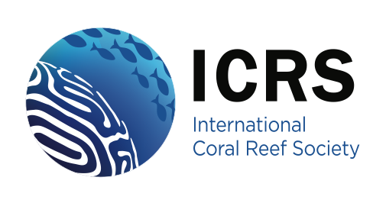
ICRS Coral Reef Conservation Award

Coral Reef Conservation Award - Up to two awards will be made annually in recognition of a regionally or globally significant contribution to the protection of coral reefs through achievements in one or more of the following fields:
- The establishment and / or management of marine protected areas
- The securing at a national or regional scale of other significant measures directed at protecting coral reefs,
- The promotion through environmental education of widespread public awareness of the need to conserve coral reefs
- Research into the scientific, social and/or environmental economic aspects of coral reef protection and management
- Research into or achievement of effective coral reef restoration
There is no educational requirement for this award, but a nomination must include in the submission documents or the nominee’s CV sufficient detail to enable the judging panel to assess the application fairly. To be eligible for this award, a nominee should be a current paid-up member of the Society and have been a member of the Society for minimum sum of THREE (3) years (either continuously or with breaks).
The nomination should consist of a) a completed ICRS award application form, b) a letter of nomination (not >500 words) submitted by a current member plus two letters of support (not > 500 words), which, for this award, may be from a member or a non-member, c) a copy of the nominees c.v. These should be assembled in to a single digital and submitted by email to the chair of the ICRS awards committee (currently Lisa Rodrigues email: lisa.rodrigues@villanova.edu).
Notes:
- Either one or two awards may be made in any year. Two prizes may be awarded where it is difficult to separate leading nominees or where it is desired to secure a balance among awardees e.g. between developed and developing countries or between genders.
- The awards each include a cash prize of US$2,500; this sum may be spent by each winner at their own discretion in relation to their personal coral reef activities and marine conservation goals, subject only to submission of receipts within a period of two years.
- The phrase “regionally or globally significant” is not meant to imply that work or activities may not be limited to a single country or part of a country, but if so limited in geographic scope they should nevertheless be of international importance.
- The successful nominee’s achievements may have been limited to one or a few of the listed fields or spread across most or all of them; it is the overall achievement across the fields which will be assessed.
- A considerable body of achievement over 10 or more years is likely to be required to secure the award (i.e. the successful nominee is unlikely to have worked in only one marine protected area or have been active in only one reef conservation or research program).
- The award winners will be expected to write an article for REEF ENCOUNTER reviewing their work and / or give a presentation about their work at an upcoming International Coral Reef Symposium.
- The judging panel for this award will be constituted from equal numbers (initially 3 each) of the ICRS Awards Committee and the ICRS Conservation Committee.

